Anthony Bugatto

Lab 5: Insertion Loss Method LPF

April 20, 2018

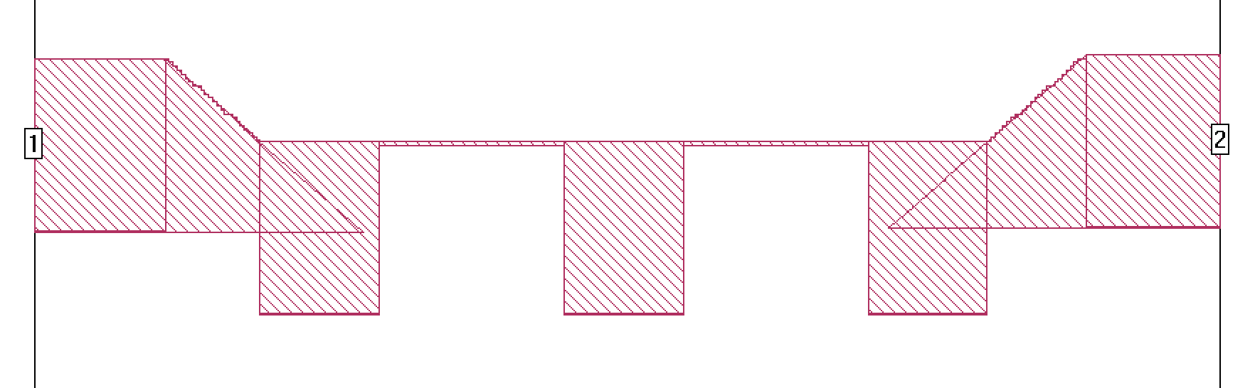

Figure 1: Schematic

This project seemed like it was going very well until I finished the schematic and tried to compile it. Unfortunately, the file was too large for sonnet lite to work with so I couldn’t retrieve the data.

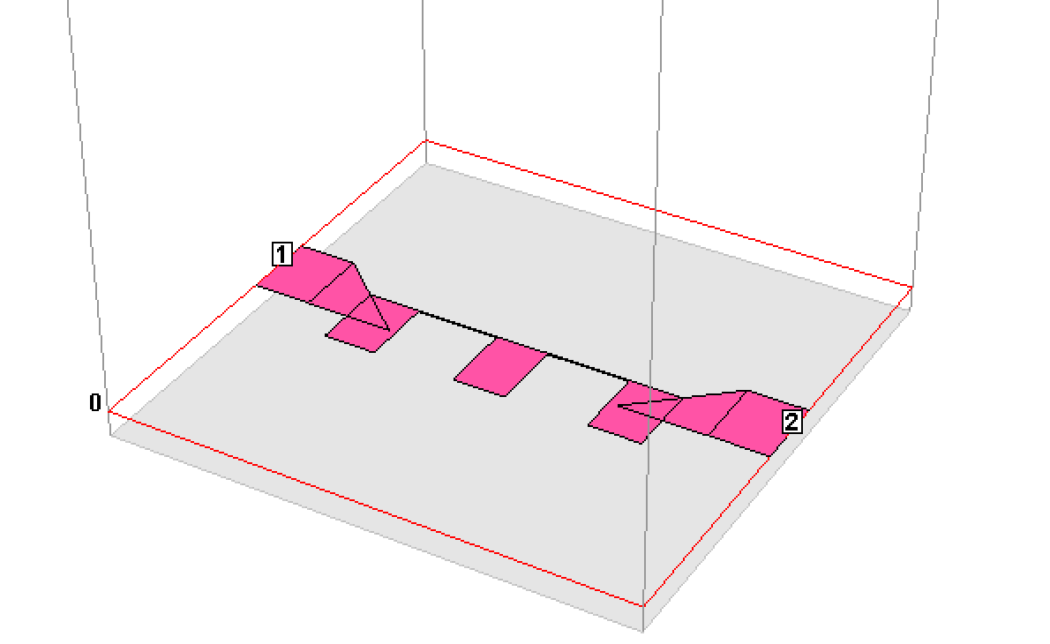

Figure 2: 3D Model

The design process used the insertion loss method, a method that is based on how much power each port loses at port 1. This is power can be represented as a polynomial with the coefficients being a parameter for the different elements of the filter. In this case we used a 3dB equal ripple (chebyshev) filter in order to get a high attenuation upon cutoff. What we would’ve seen for S12 is a small ripple effect in the pass band from 0 to 6GHz and then a steep attenuation after that. For S11 we would’ve seen nearly no reflection in the pass band and then a sharp reflection on the stop band. In order to design this I used the impedances found as well as other data given to calculate the legnths given on the design model.